II International Workshop and School of Young Scientists:

Theory, experiments and numerical simulations of reaction-diffusion systems in applications for biotechnology, biomedicine and
energy production

27 September – 1 October 2021
Vladivostok State University of Economics and Service,
Vladivostok, Russia

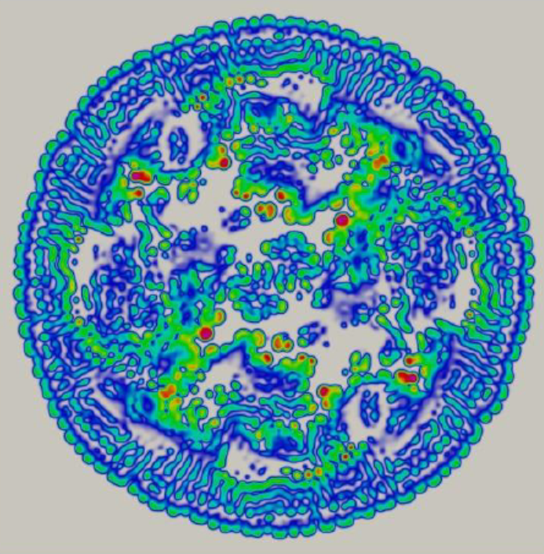

Major topics
- Modelling and computational issues of combustion phenomenon
- Dynamic behavior, pattern formation in biological systems in the flows
- Modeling of gas bubbles dynamics in liquid under laser radiation in applications
for laser surgery and others
- Direct numerical simulations of turbulence from the first principles
- Modern computational methods and modeling of no equilibrium dynamics of
inhomogeneous media and quantum informatics
Scientific committee:
Mikhail A. Guzev (IAM FEB RAS, Vladivostok, Russia),
Junnosuke Okajima (IFS Tohoku University, Japan),
Kaoru Maruta (IFS Tohoku University, Japan)
Nikolay N. Smirnov (MSU, Moscow, Russia)
Sergey S. Minaev (IAM FEB RAS, Vladivostok, Russia),
VladimirV. Gubernov (P.N.Lebedev Physical Institute, Moscow, Russia),
Roman V. Fursenko (ITAM SB RAS, Novosibirsk, Russia),
Valerii I.Babushok (KTC Consulting, Gaithersburg, MD, USA)
Vadim Kurdyumov (Department of Energy, CIEMAT, Madrid, Spain)
Vyasheslav Bykov (Karlsruhe Institute of Technology, Germany)
Gennady V. Alekseev (IAM FEB RAS, Vladivostok, Russia)
Aleksander Yu. Chebotarev (IAM FEB RAS, Vladivostok, Russia)
KonstantinV. Nefedev (FEFU, Vladivostok, Russia)
Denis A. Knyazkov (ICKC SB RAS, Novosibirsk, Russia)

Organizing committee:
Sergey S. Minaev, Vladimir V. Gubernov, Evgenii P. Dats

Local organizing committee:
Evgenii Dats, Evgenya Abrosimova (VSUES, Russia)

Conference email: minaevss@yahoo.com

Supported by

Institute for Applied Mathematics Far Eastern Branch of Russian Academy Sciences
Vladivostok State University of Economics and Service (VSUES, Russia)
Combustion Institute Russian Branch
Ministry of Science and Higher Education of the Russian Federation (project №075-15-2019-1878)

Announcement:
We would like to invite you to participate in the workshop and school of young scientists:
“Theory, experiments and numerical simulations of reaction-diffusion systems in applications for biotechnology, biomedicine and energy production” which will be held in Vladivostok, Vladivostok State University of Economics and Service (VSUES), Russia from 27 September to 1 October 2021. The hybrid conference assumes on-line and personal presentations. The main idea of the conference is to bring together the leading experts in the field of modelling and computation of reaction-diffusion systems and to facilitate collaboration between them. The development of a universal approach in simulations of different reaction-diffusion systems is the focus of the conference. The conference will be hold in the centre of Vladivostok city, which has great opportunities for sightseeing, yachting, fishing and many more. The program of the seminar will allow the participants to enjoy these possibilities alongside with discussing scientific problems. The working language is English

